IT Support Report

Luz E Cabrera Rios
Department of Computer Technology and Information Systems, Wayne State College
CIS-472: Advanced Hardware
Jeremy Wynia
April 1, 2025

IT Support Report
Project Summary
Report # | Report Date | Technician Name
12345 | April 1, 2025 | Luz Cabrera
Customer Name | Customer Address | Customer Contact
Willy The Wildcat | 1111 Main st | wsc@wsc.edu

Customer Device Information
 | Desktop/Laptop/Workstation/Other
  What kind of device is it?
 | Windows/Linux/macOS/Other
  What operating system is running?
 | Pre-built/Custom-build
  Was the device pre-built or custom-built?
Date when device received | January 2, 2025
Components | CPU: Ryzen 5 2600x  GPU: PNY GTX 1650 Super  MOBO: MSI x470  RAM: XPG 2x8gb DDR4  PSU: EVGA BR 550W  Storage: NVME gen 3 500gb

Customer Problem Report
Problem Report | The customer states that the computer was functioning normally but suddenly froze. After attempting a restart, the system failed to boot.
When trying to boot the computer, do you see any image? | Yes/No
When was the last time the system was updated? | Not Sure
Have you tried using a different video output port? | Yes/No
Have you attempted using another power cable or outlet? | Yes/No
Were you attempting to install any software during your last session? | Yes/No
When trying to boot the computer, do you see any lights coming from the computer? | Yes/No

Listings & Findings
Initial Theory | Initially, I suspected an OS corruption error since the computer froze and would not boot. However, when attempting to recreate the problem, the computer did not complete the POST.
Power Supply | Tested the PSU with a dedicated tester and in another functional system – no issues were found.
POST Analysis
Motherboard POST | The “EZ debug” feature showed “2” and “3” error codes, which is related to RAM and Video errors.
CPU | Not errors indicated.
RAM | - RAM error light was on.  - Swapped the RAM and tested it in another system - confirmed the RAM was functioning properly.  - Tested a different brand of RAM in customer’s computer – resulted in a VGA error
VGA (Video) | - Customer’s GPU tested fine in another system.  - Installing a different GPU in the customer’s computer still produced a VGA error, suggesting the problem was not with the graphics card itself.

Actions Taken
RAM Testing | - Removed and swapped the original RAM.  - Tested the RAM in another system.  - Installed an alternative brand of RAM in the customer’s PC, which then showed a VGA error.  - Swapped original RAM back – Showed the VGA error still.
GPU Testing | Verified the customer's GPU in another functional system – confirmed it works.  Installed an alternative GPU in the customer's PC, and the VGA error persisted.
Power Supply Verification | Tested the PSU using a PSU tester.  Confirmed proper voltage and functionality in another system.
Motherboard and BIOS Checks | - Checked the EZdebug LED – error “4” was active, indicating a POST failure.  - Reset the BIOS by removing the CMOS battery and using the reset button – issue persisted.  - Visually inspected the motherboard for physical damage or burnt components – nothing was found.  - Considered a corrupted BIOS as a potential cause.
BIOS Recovery Attempt | Noticed that the motherboard did not offer a USB BIOS update function.  Installed a CPU with integrated graphics (a workaround) to gain access to the BIOS.  Successfully updated the BIOS after gaining access.

Actual Problem Found
 | The root cause of the boot failure was a corrupted BIOS on the motherboard.
  Diagnosis
 | Installing a CPU with integrated graphics allowed access to the BIOS.  After updating the BIOS to the latest version, the system passed POST successfully and all original user components were reinstalled.  The computer booted normally after the BIOS update.
  Resolution

Common Reasons for BIOS Corruption
Power Surges/Instability | Fluctuations in power supply can cause interruptions during system operation or BIOS updates.
Failed BIOS Update | An interrupted or faulty BIOS update process can leave the BIOS in a corrupted state.
Hardware Faults | Defective components (such as a failing PSU) can sometimes send erroneous signals that may corrupt the BIOS settings.
Environmental Factors | Overheating or moisture exposure can contribute to electrical faults, potentially affecting the BIOS.
User Error | Incorrect configuration settings or inadvertent actions during system maintenance can sometimes lead to BIOS corruption.

Images of progress:
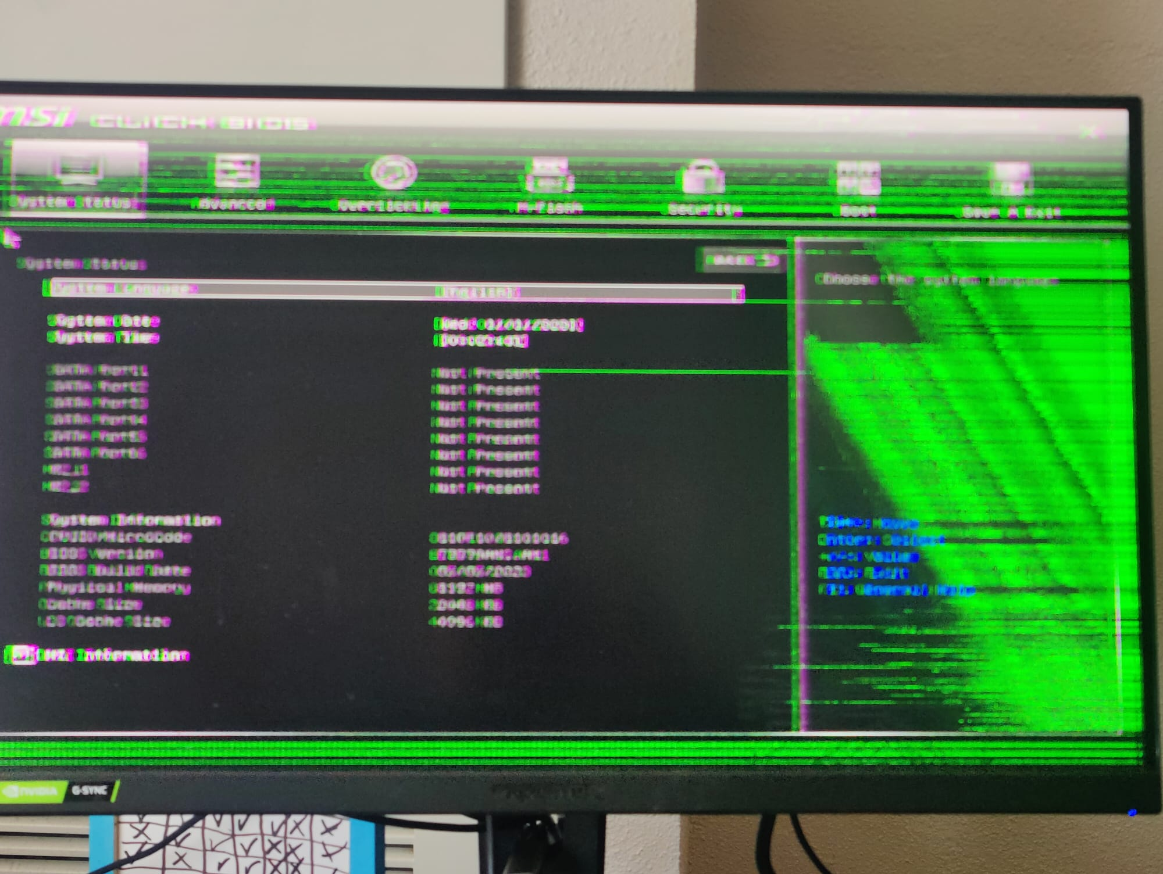
CPU integrated graphics work around.
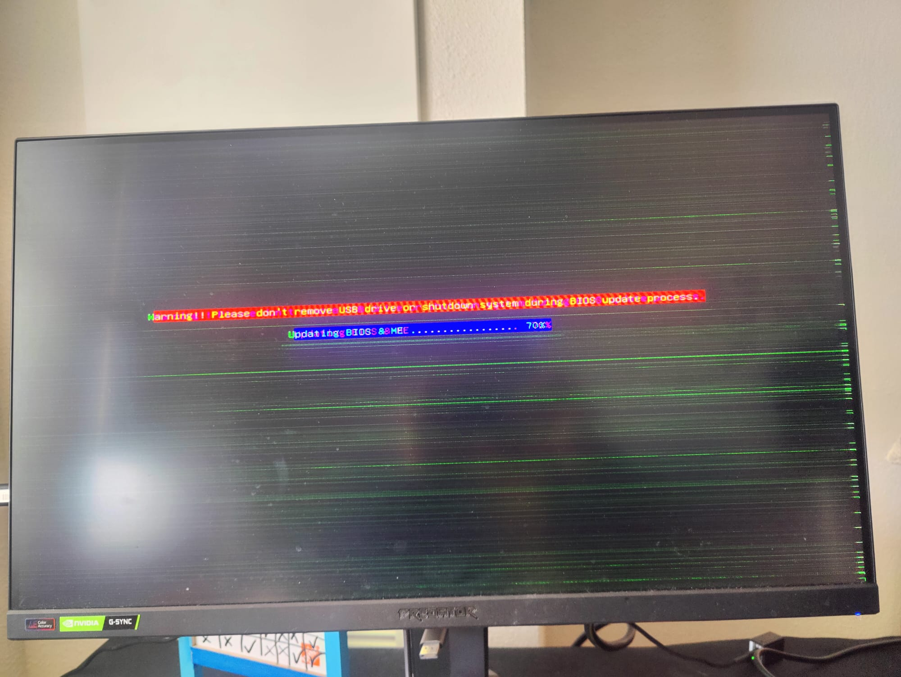
Updating BIOS with the CPU workaround.
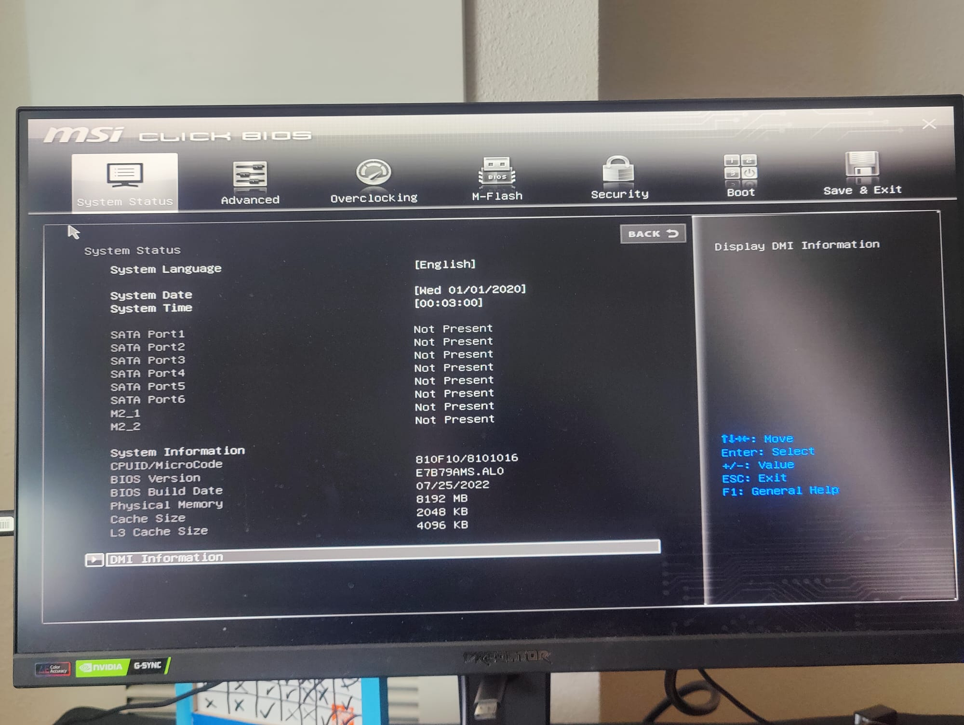
Swapped CPUs and installed GPU.

